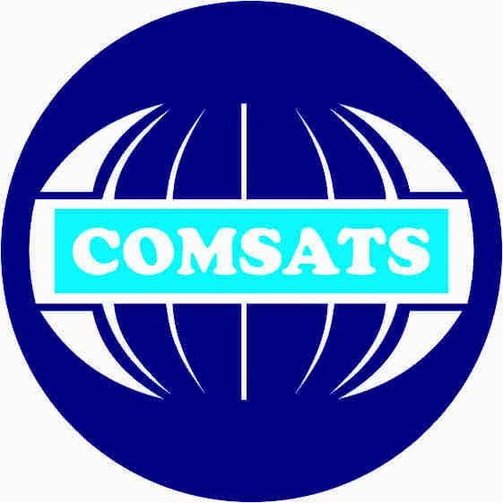

**MAD Theory Assignment#1**

## Submitted by:

Muhammad Usman (fa19-bcs-124)

## Submitted To:

Mr. Muhammad Kamran

**Dat**e: Oct 2, 2022

**Q1: A comparison of Native and Cross Platform mobile app development:**

**Native Mobile App Development:**

Native Mobile app development platform is use to build apps for a particular operating system. Either Android or iOS.

* We write code in a specific language depending upon operating system.
* Native Apps have fast performance due to platform specific.
* Native Development cost is high because you need teams of different developers for different languages.
* Native development use more time because Separate teams working on similar apps for separate platforms take time.
* You cannot reuse the code in Native platform.

**Cross Mobile App Development:**

* Cross Mobile app development platform is use to build apps for different operating systems. Cross platforms apps can be deployed on both Android and iOS.
* Cross platform use a single base code for developing applications.
* Cost for cross app development is less as compare to Native. Because development need only a single team of developer.
* Cross Development use less time as Comair to Native.
* Updating a cross-platform app is easier. This is because you are dealing with a single codebase.
* Code reusability is allowed in Cross plate form.

**Q2: Different scenarios where each native and cross platform mobile app development is preferred.**

You should choose native development if your application requires full access to all of the phone resources and services. You want to build the most responsive application .You're looking to take full advantage of the mobile phone's hardware .You want an app that can be easily updated and enhanced with new features in the future.

You should choose Cross-Platform development if You are ready to accept a less responsive app .The application does not involve complex animation nor deal with complicated logic .You have a short window to test an idea and hypothesis in the app market. In some projects, you’ll want to get an MVP app up as soon as possible. This is where you’ll want to consider cross-platform development. You don’t have to work on two versions of the app. Instead, only a single cycle of development is needed for an APP to be released for Android and iOS.

**Q3: List of frameworks/Tech Stack for cross platform mobile Application development:**

**1. Ionic:**  It allows developers to use a combination of top programming languages i.e., HTML5, JavaScript, and CSS and Cordova wrapper to access native platform controllers.

**2. React Native:** It is a framework built on JavaScript and is used to write real code and give the native-like feel to mobile applications that work both on Android and iOS.

**3 Flutter:**  is a software development kit designed to assist in the expeditious Android and iOS app development. It is also a fundamental and primary method for developing Google apps.

**4 Xamarin:**  It is a streamlined framework used for developing apps for Android, Windows, and iOS with the help of C# and .Net.